YouTube Streamer Analysis

Oluwatomisin Jegede

2024-09-09

# Introduction

This report presents a comprehensive analysis of the top YouTube streamers based on various performance metrics, including subscribers, likes, comments, and visits. The dataset contains information on streamer categories, audience engagement, and geographic distribution. Several key insights were derived, focusing on trends in content categories, regional preferences, and streamer performance.

# Data Exploration and Cleaning

The dataset initially contained inconsistencies in content categories and country names, which were corrected through a detailed cleaning process in Excel. Common errors included mislabeling popular K-pop groups (e.g., BTS labeled as India) and musicians such as David Guetta (Brazil to France).

In this analysis, I identified outliers in several numeric variables, including Visits, Likes, and Comments, using the IQR method. Given the dataset’s relatively small size (1000 rows), the outliers represent a significant portion of the data. These outliers are likely associated with exceptionally popular YouTube channels, which are crucial for understanding the extremes in the data.

Removing these outliers could distort the overall analysis and eliminate valuable insights into high-impact channels. To ensure the robustness of my findings, I conducted additional checks by analyzing the data both with and without outliers. The results confirmed that the presence of these outliers does not substantially alter the overall conclusions of our study.

Therefore, I have chosen to retain the outliers in the analysis to preserve the integrity of the dataset and fully capture the range of channel performance metrics.

# Trend Analysis

## Content Categories and Popularity

I explored the distribution of streamers across different content categories and identified which categories have the highest number of streamers.’Music, Movies, Animation, Dance, Daily Vlogs, News and Politics’ are the top content categories. This information is visualized on a coloured table in Tableau but due to the size of the table, a link is provided below:

[Most Popular YouTube Content Categories](https://public.tableau.com/views/AnOverviewoftheTopYouTubeStreamers/MostPopularYoutubeCategories?:language=en-GB&:sid=&:display_count=n&:origin=viz_share_link)

This visualization provides a clear view of which content categories have the most YouTube streamers and correlates it with their overall performance.

## Content Category Analysis

The bar charts below highlights the average number of subscribers, likes, and comments across different content categories, helping us understand which categories engage audiences the most.

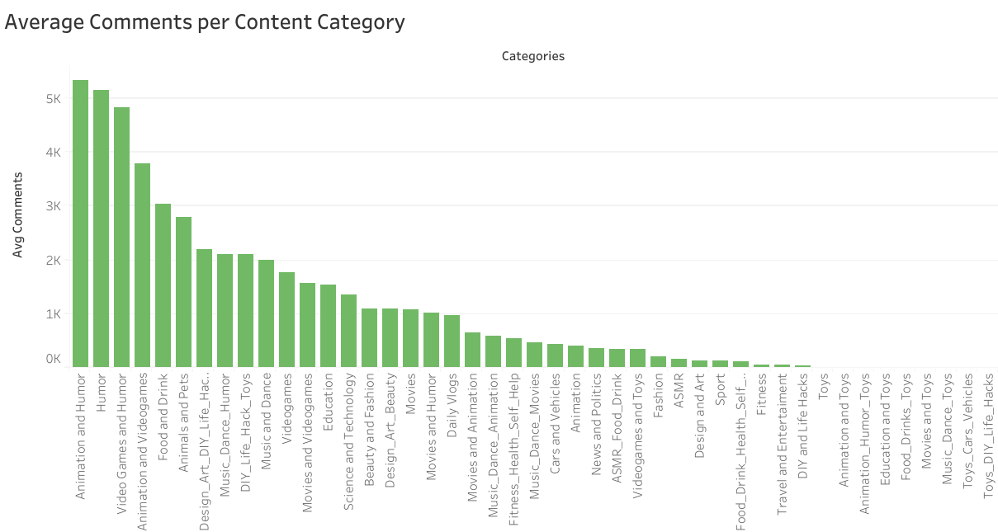

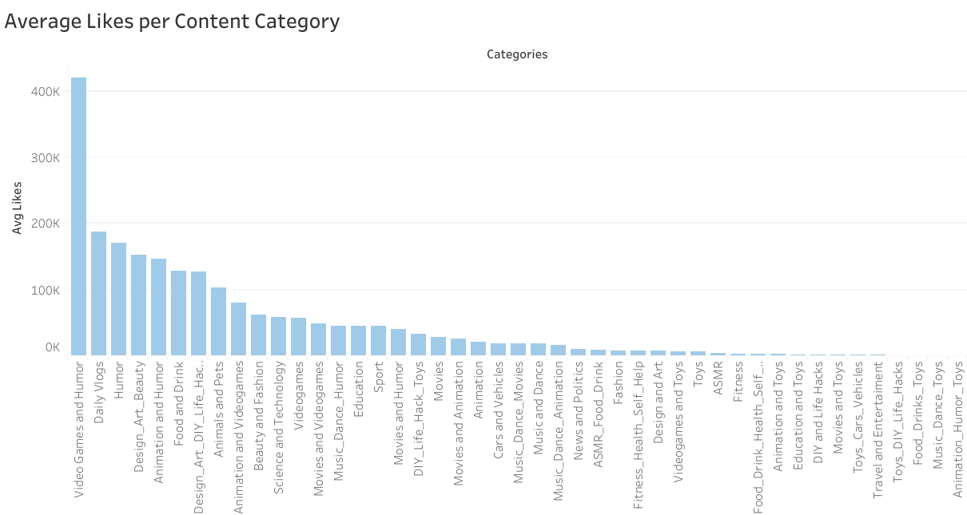

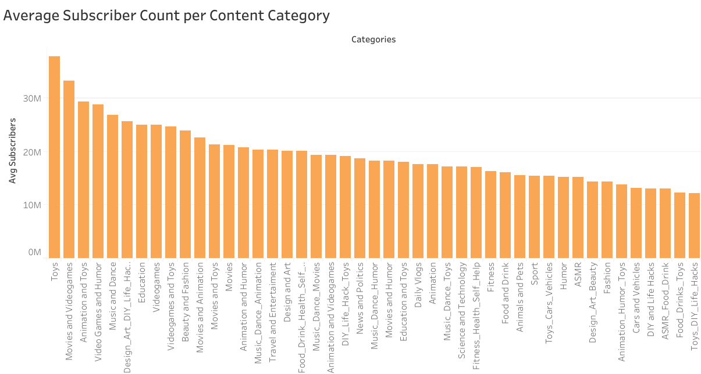

The categories ‘Animation’, ‘Humor’, ‘Video Games’ rank among the top in all engagement metrics.

## Audience Study

This section explores the distribution of streamers across various countries and their corresponding content preferences.

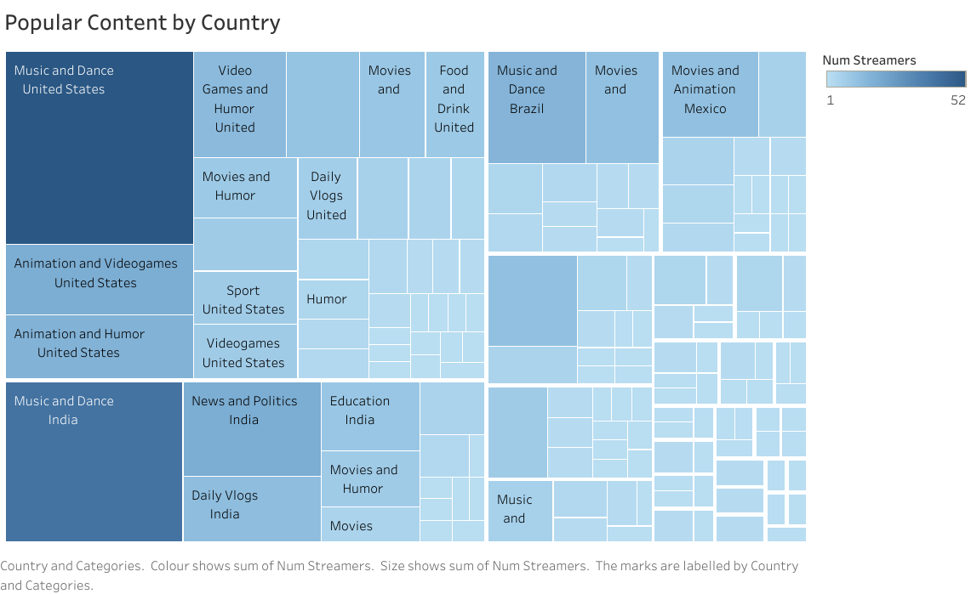

The tree map above provides insights into regional content preferences, with categories like ‘Music and Dance’ being dominant in countries like the United States, India, and Brazil. ‘Daily Vlogs’ is a also a popular content category in the United States and India. As well as ‘Animation’ and ‘Video Games’ being popular in the United States.

## Performance Metrics and KPI

I calculated the average number of subscribers, likes, comments, and visits. However, due to data inconsistencies in the likes, comments, and visits columns, subscribers was used as the key performance metric.

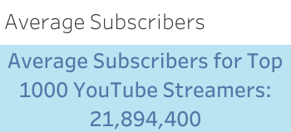

The KPI above displays the average number of subscribers as 21.89 million across all streamers.

Next, I analyzed streamers who performed above average in terms of subscribers. A detailed table was created to list these streamers.Top streamers include ‘Tseries’, ‘Mr Beast’, ‘Coco Melon’, ‘SET India’ among others. Given the table’s size, a link to the full table in Tableau is provided below:

[Streamers with Above Average Subscribers](https://public.tableau.com/views/AnOverviewoftheTopYouTubeStreamers/StreamerswithAboveAverageSubscribers?:language=en-GB&:sid=&:display_count=n&:origin=viz_share_link)

Additionally I created a **dashboard in Tableau** to show an overview of the key performance insights of YouTube streamers. The dashboard as well as a link to the dashboard is provided below: 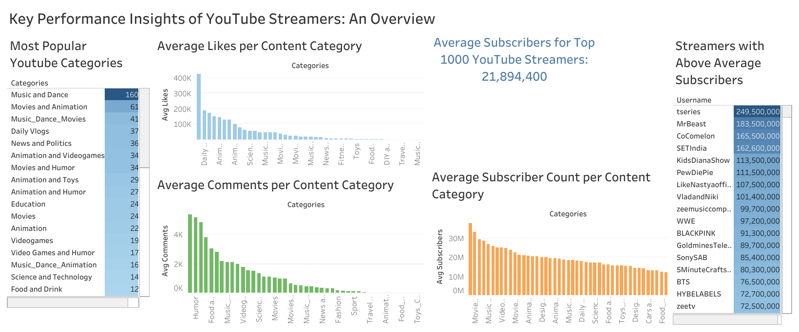 [Tableau Dashboard](https://public.tableau.com/views/AnOverviewoftheTopYouTubeStreamers/KeyPerformanceInsightsofYouTubeStreamersAnOverview?:language=en-GB&:sid=&:display_count=n&:origin=viz_share_link)

# Conclusion and Recommendations

After thoroughly analyzing the dataset and visualizing key performance metrics, I have provided the following recommendations to YouTube and content creators:

* Enhance Content Recommendations:

Based on our analysis, categories like Music, Gaming, and Entertainment dominate the platform. YouTube can use this information to enhance its content recommendation system by suggesting similar content to viewers with interest in these categories.

* Leverage Regional Preferences:

The data indicates strong regional preferences for certain categories, such as Music in the United States and Movies in Mexico. YouTube could offer more tailored regional marketing campaigns based on these preferences.

* Focus on Subscriber Growth:

Given that subscribers are the most stable performance metric, content creators should focus on building strong subscriber bases through consistent content and collaborations with top-performing streamers.

* Collaborate with High-Performing Streamers:

Streamers with above-average subscribers are likely to receive more brand collaborations. Companies looking for effective marketing campaigns should target streamers within Gaming, Music, and Entertainment for their high reach and engagement rates.

**Next Steps** Future analysis could focus on refining the dataset by including more accurate engagement metrics such as audience geographic distribution, which would provide deeper insights into regional preferences. Additionally, addressing the data quality issues observed with likes, comments, and visits would enhance the accuracy of future studies.